OpenNMS has a number of ways to perform automated discovery, but sometimes it is better to just tell OpenNMS what to monitor. A case in point would be a remote router accessed via DSL where the IP address is set via DHCP. If that address changes, OpenNMS may have no way of knowing that automatically.
Provisioning Groups is an administrative GUI option that provides a front end to the Importer Service. It works by allow a "group" to be created that consists of "nodes". For each node, the IP address and services on that IP address can be set manually. Access this GUI via Admin -> Manage Provisioning Groups.
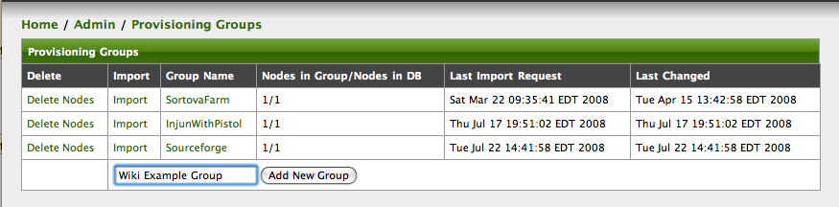
Add a new group, in this case "Wiki Example Group" and press the "Add New Group" button.
At this point it will be added to the list of groups. Click on the group name (Wiki Example Group) to be able to add devices to it.
Add the Node (setting the name, etc.), add interfaces, and add services to those interfaces. The "ForeignId" key will be randomly generated and can be left alone, but it is very important since it indicates the unique key that will identify the device in the system. Usually when using the Importer this key will relate the OpenNMS node to the device in the remote database.
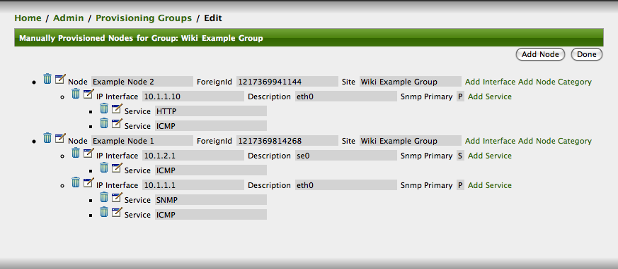
Press the Done button when finished and it will return to the main Provisioning Groups menu.
The remaining step is to hit the "Synchronize" link which will cause all of the devices in the group to be added to OpenNMS. From this point on they are managed just like any other device in the system.
If anything should change on these devices, such as an IP address, simply return to this screen and click on the group name to edit it. When finished, re-import the file and the changes will take effect immediately.

